1. 本次测试的测试环境如下：操作系统Ubuntu20.04，硬盘60G，内存1G，处理器1个。
2. 将操作系统内的镜像源改为国内镜像源，在终端输入sudo gedit /etc/apt/sources.list，将内容改为如下镜像源，并保存退出：

deb http://mirrors.aliyun.com/ubuntu/ focal main restricted universe multiverse

deb-src http://mirrors.aliyun.com/ubuntu/ focal main restricted universe multiverse

deb http://mirrors.aliyun.com/ubuntu/ focal-security main restricted universe multiverse

deb-src http://mirrors.aliyun.com/ubuntu/ focal-security main restricted universe multiverse

deb http://mirrors.aliyun.com/ubuntu/ focal-updates main restricted universe multiverse

deb-src http://mirrors.aliyun.com/ubuntu/ focal-updates main restricted universe multiverse

deb http://mirrors.aliyun.com/ubuntu/ focal-proposed main restricted universe multiverse

deb-src http://mirrors.aliyun.com/ubuntu/ focal-proposed main restricted universe multiverse

deb http://mirrors.aliyun.com/ubuntu/ focal-backports main restricted universe multiverse

deb-src http://mirrors.aliyun.com/ubuntu/ focal-backports main restricted universe multiverse

1. 下载qemu，并编译安装

mkdir ~/openEuler/

mkdir ~/openEuler/RISC-V

cd ~/openEuler/RISC-V

wget https://download.qemu.org/qemu-7.0.0.tar.xz

tar xnJf qemu-7.0.0.tar.xz

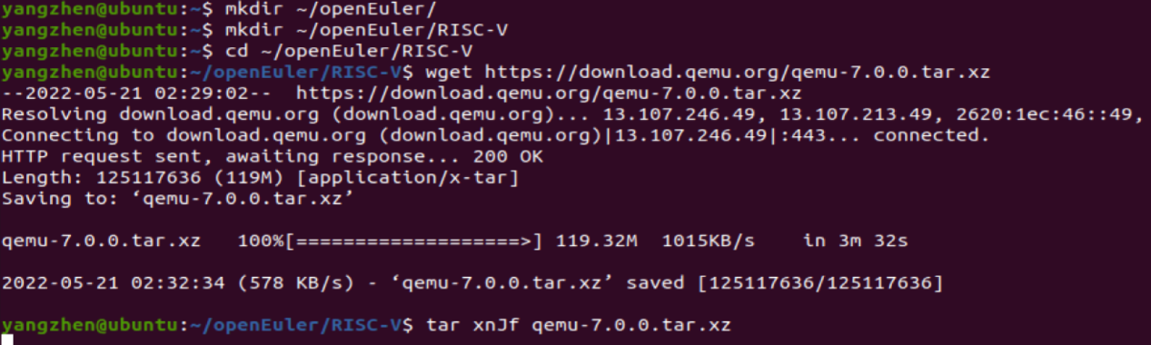

cd qemu-7.0.0

sudo apt-get install build-essential zlib1g-dev pkg-config libglib2.0-dev binutils-dev libboost-all-dev autoconf libtool libssl-dev libpixman-1-dev python-dev python3-pip python-capstone virtualenv

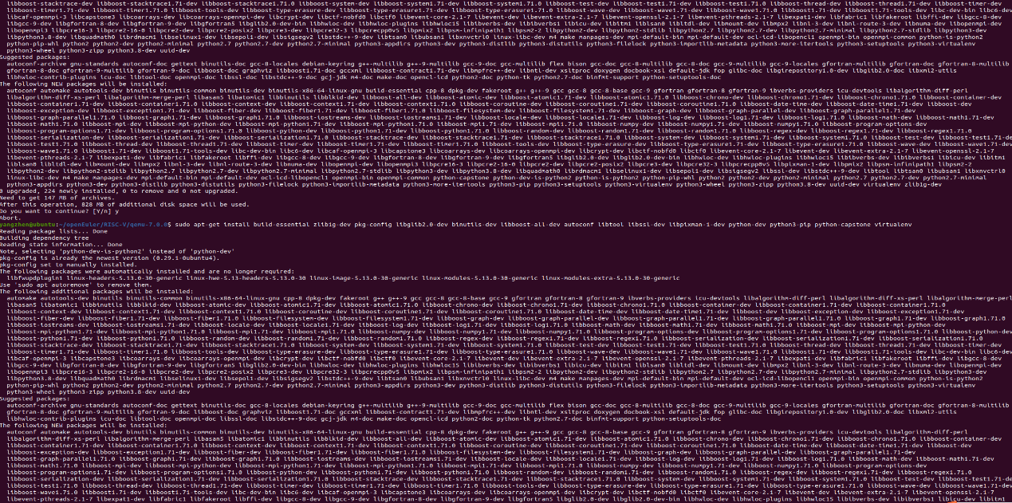

ninja-build

./configure --target-list=riscv64-softmmu,riscv64-linux-user --prefix=/home/civy/openEuler/RISC-V/program/riscv64-qemu

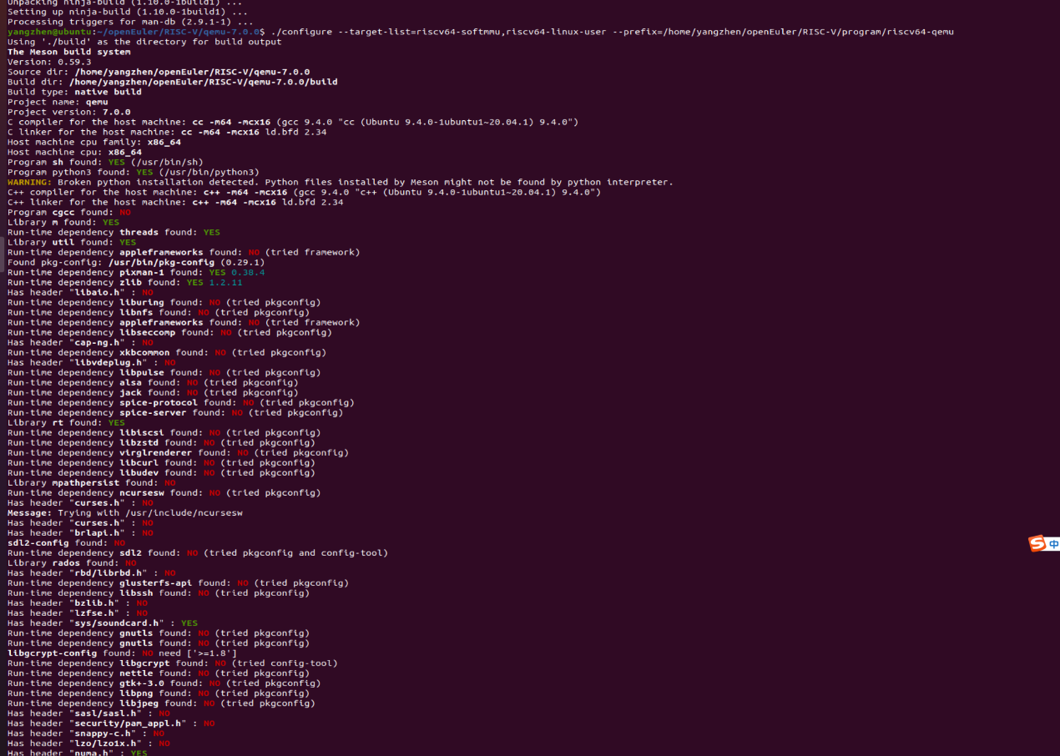

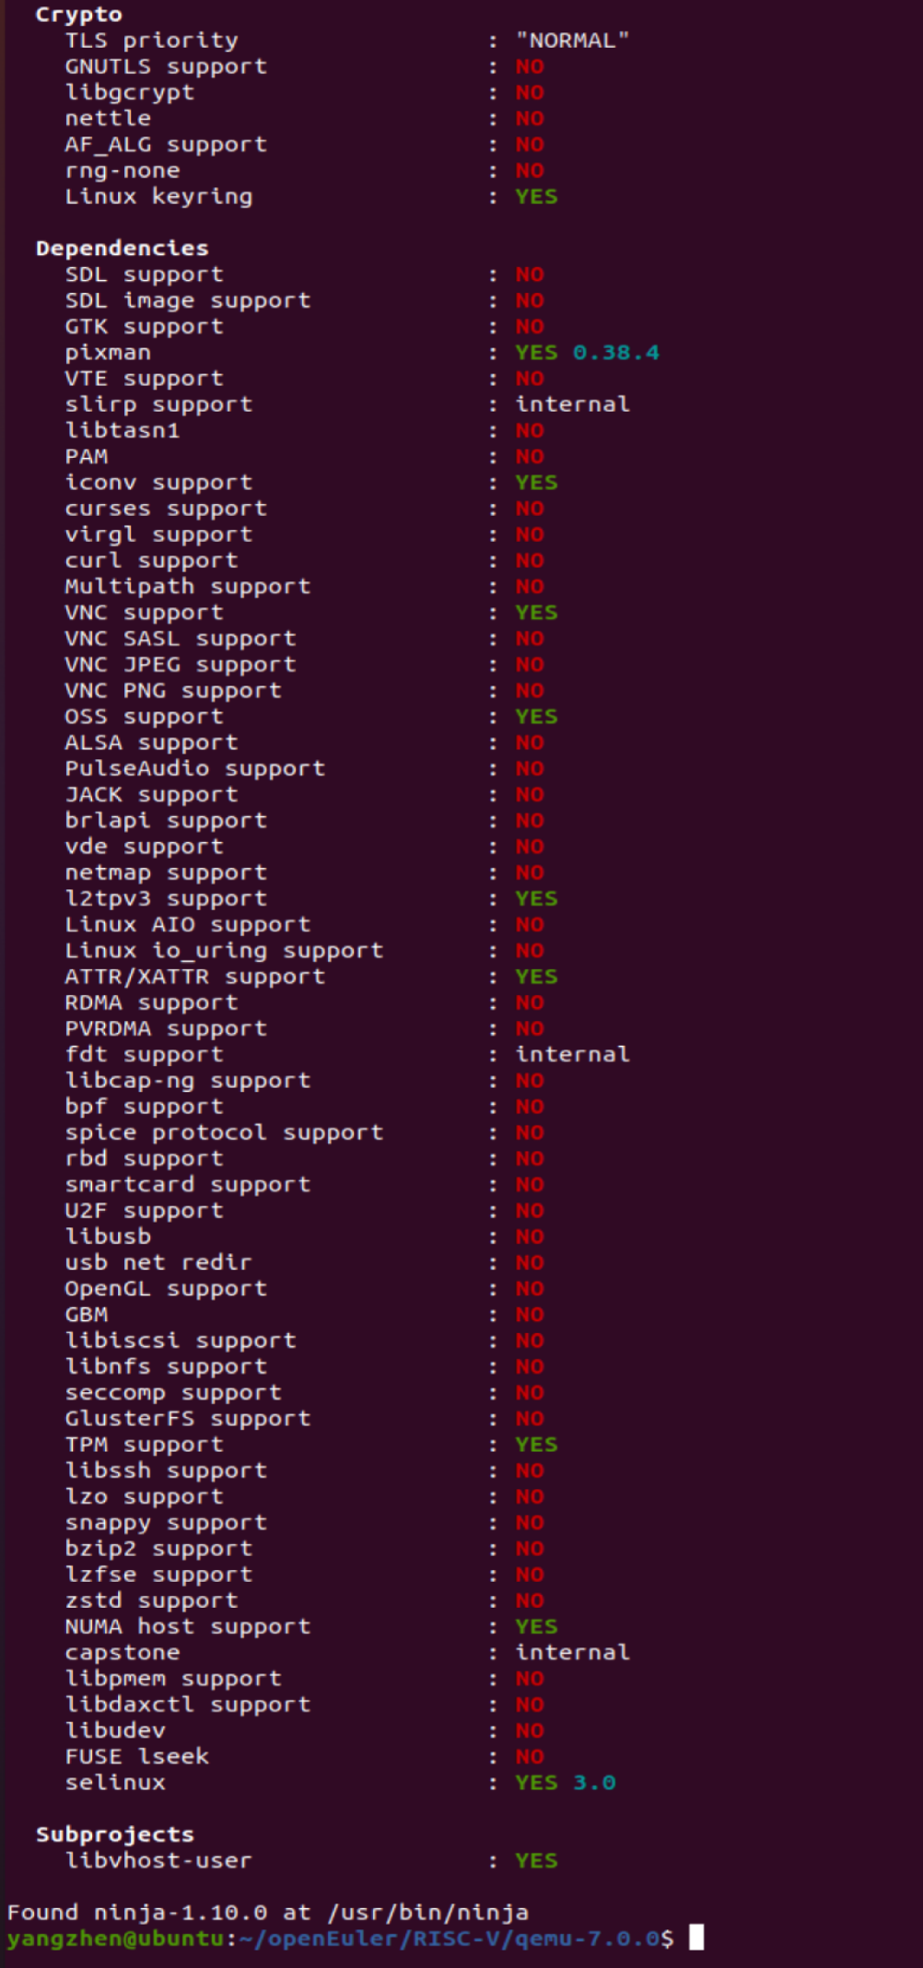

再继续输入如下命令：

make

make install

在openEuler/RISC-V文件夹中新建空文件夹program/riscv64-qemu，再设置环境变量：

gedit ~/.bashrc

在文件中加入如下内容：

export QEMU_HOME=/home/yangzhen/openEuler/RISC-V/program/riscv64-qemu

export PATH=$QEMU_HOME/bin:$PATH

保存退出，新建一个终端，echo $PATH，查看环境变量是否配置成功：

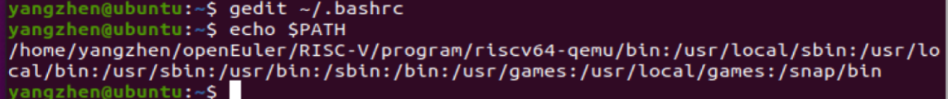

接着验证安装是否正确：

qemu-system-riscv64 –version



1. 下载OpenEuler RISC- V镜像

cd ~/openEuler/RISC-V

wget https://repo.openeuler.org/openEuler-preview/RISC-V/Image/fw_payload_oe.elf --no-check-certificate

wget <https://repo.openeuler.org/openEuler-preview/RISC-V/Image/openEuler-preview.riscv64.qcow2>

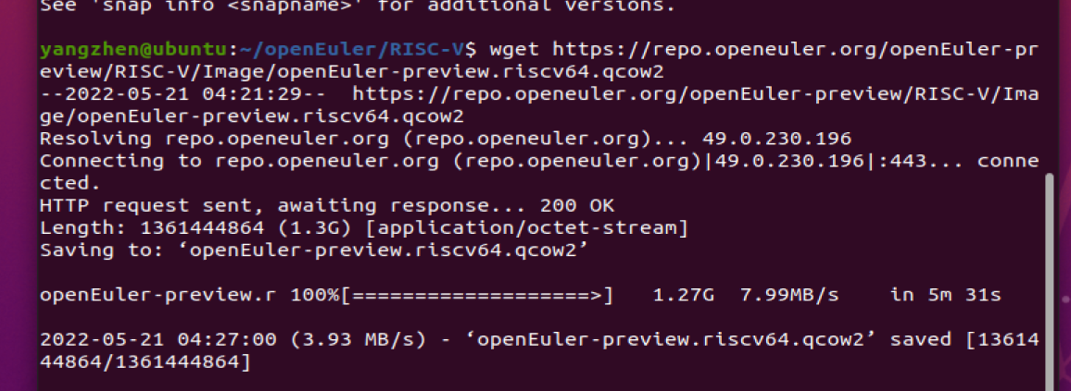

git clone https://gitee.com/yunxiangluo/riscv-openeuler.git

vim run.sh

gedit run.sh

在打开的文件中输入以下内容：

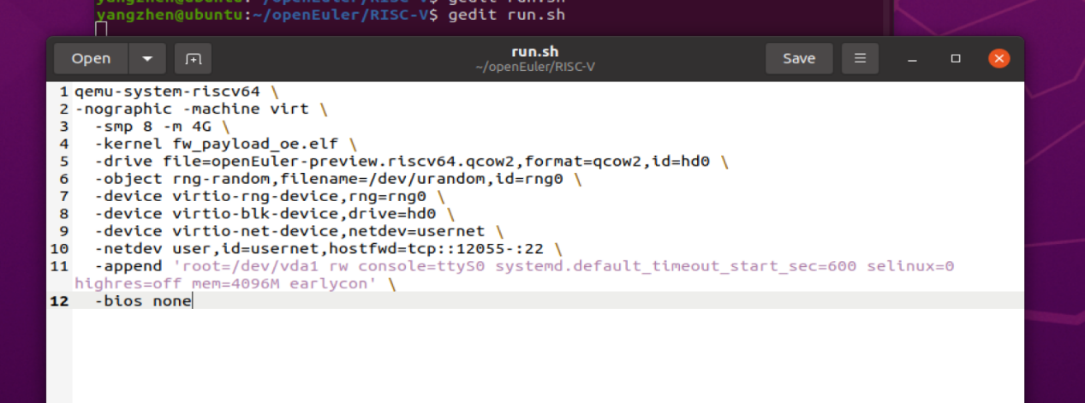

chmod +x run.sh

./run.sh

提示无法分配内存，

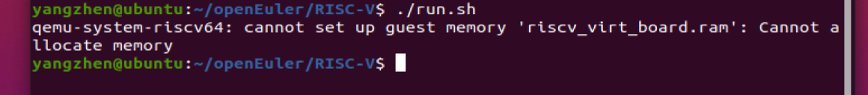

于是再将文件中的内容容量改小：

第三行改为：

-smp 1 -m 2G \

再次运行：

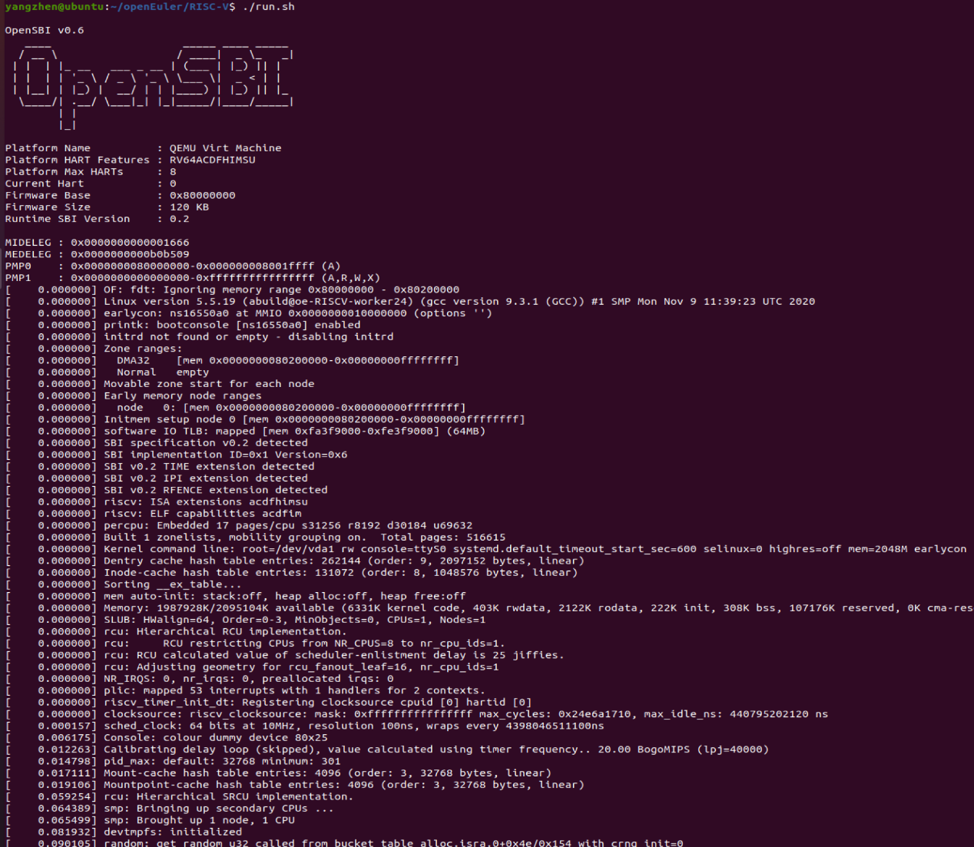

输入登录用户名：root 默认密码：openEuler12#$

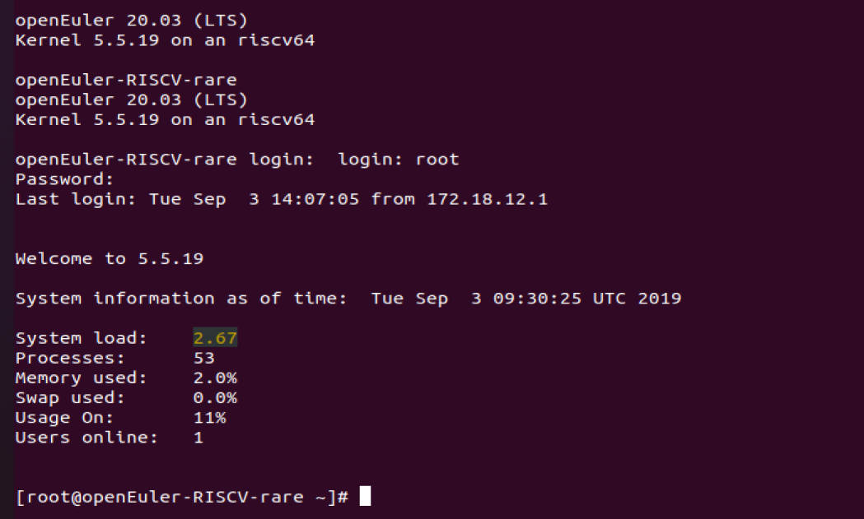

1. 安装运行测试neofetch

新建终端并执行：

git clone https://github.com/dylanaraps/neofetch

scp -P 12055 -r neofetch/ [root@127.0.0.1:./](mailto:root@127.0.0.1:./)

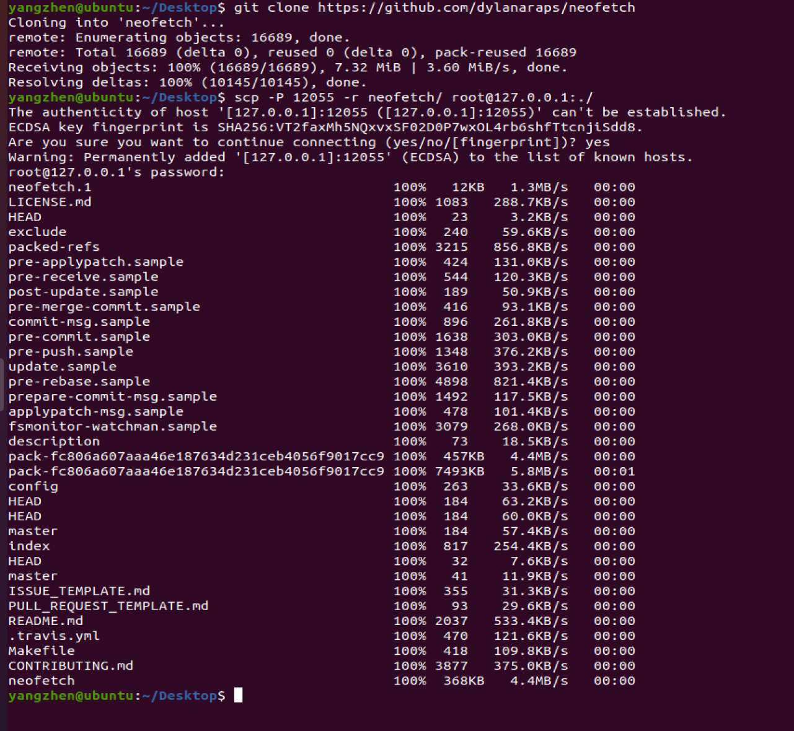

在原来的终端中执行：

cd neofetch/

sudo make install

Neofetch

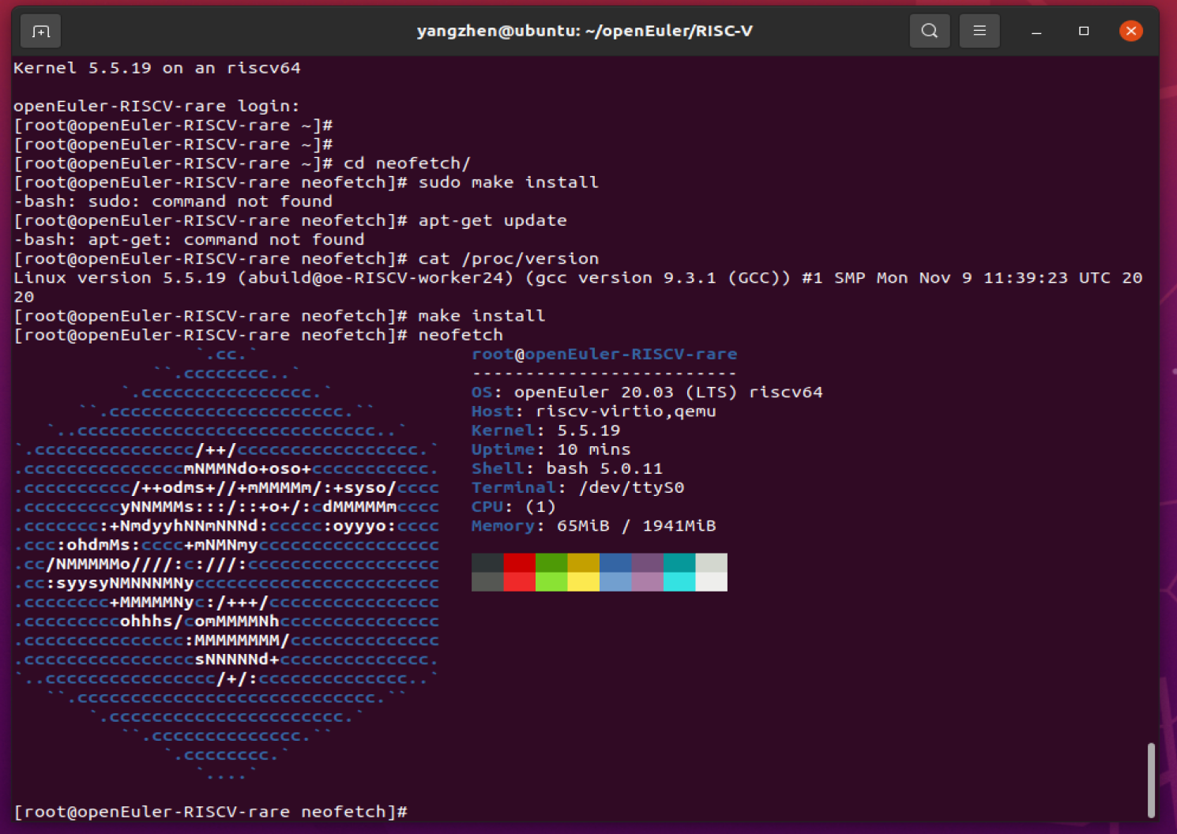

至此，安装完成！